Graphene Molecules by Design
Klaus Müllen
Max Planck Institute for Polymer Research, Mainz, Germany
muellen@mpip-mainz.mpg.de
Our approach toward graphenes relies on making polycyclic aromatic hydrocarbons (PAHs) larger and larger. Three-dimensional (3D) dendritic oligo- and polyphenylene precursors are subjected to a cyclodehydrogenation leading to a flattening (graphitization) into disc structures. We introduce synthetic approaches to graphene nanoribbons GNRs with defined lengths (up to 600 nm) and widths (several nm). In comparison to classical solution polymer chemistry, we immobilized monomers and thermally produced diradicals on surfaces that underwent aryl-aryl coupling followed by cyclodehydrogenation to form GNRs. A remarkable characteristic is that the surface-bond precision syntheses of ultra-large objects can be monitored by scanning tunnelling microscopy. GNRs hold promise for replacing conventional conjugated polymers as active components in devices. Suitable alkyl substitution of nanographene molecules leads to the formation of defined supramolecular columns in discotic liquid crystalline phases.
Graphene materials and their molecularly defined derivatives will be shown to open new working principles, not only for digital electronics, but also for energy technologies such as battery cells, supercapacitors, and fuel cells.
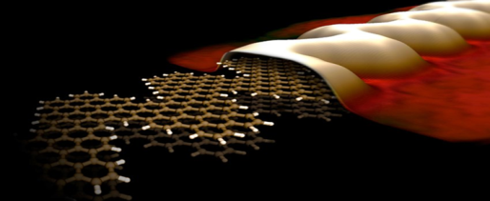
Nature Mater. 2009, 8, 421; Nature 2010, 466, 470; Angew. Chem. Int. Ed. 2010, 49, 2565; Angew. Chem. Int. Ed. 2010, 49, 4795; Nature Commun. 2010, 1, 31, DOI: 10.1038/1029; Nature Chem. 2011, 3, 61; Angew. Chem. Int. Ed. 2011, 50, 2540; ACS Nano 2011, 5, 6743; ACS Chem. Neurosci. 2011, 2, 687; Adv. Mater. 2011, 23, 3575; Chem. Mater. 2011, 23, 554; ACS Nano 2012, 6, 5539; J. Am. Chem. Soc. 2012, 134, 9082; ACS Nano 2012, 6, 2020; Angew. Chem. Int. Ed. 2012, 51, 7640; Acc. Chem. Res. 2013, 46, 116; J. Am. Chem. Soc. 2013, 135, 2060; Nature Commun. 2013, DOI:10.1038/ncomms3646; Nature Chem. 2014, 6, 126

