π-Conjugated 1D and 2D Polymers

Ullrich Scherf
Chemistry Department, BUWMakro group, and Institute for Polymer Technology, Bergische Universität Wuppertal (BUW), Gauss-Str. 20, D-42119 Wuppertal, Germany
Email: scherf@uni-wuppertal.de

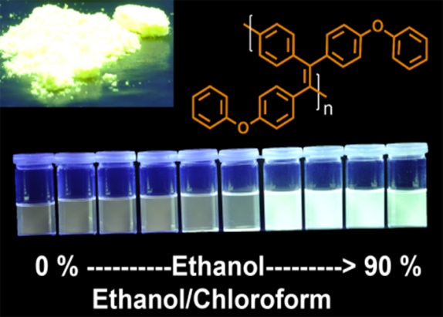

Figure 1:
AEE-active poly(para-phenylene-diphenylvinylene) derivative with solid state photoluminescence quantum yields near unity

The lecture presents some recent, synthesis-driven approaches from our synthetic polymer chemistry group on control and tuning of optical, electronic and morphological properties of π-conjugated (co)polymers. The examples involve: (i) novel conjugated ladder polymers,^{1,2} (ii) conjugated polymers with aggregation-enhanced emission (AEE) properties (see Figure 1),^{3,4} and (iii) conjugated polyelectrolytes (CPEs).⁵⁻¹¹
References
- A. Rudnick, K. J. Kass, E. Preis, U. Scherf, H. Bässler, A. Köhler, J. Chem. Phys. 2017, 146, 174903.
- K.-J. Kass, M. Forster, U. Scherf, Angew. Chem. Int. Ed. 2016, 55, 5816.
- W. Dong, T. Fei, A. Palma-Cando, U. Scherf, Polym. Chem. 2014, 5, 4048.
- S. Baysec, E. Preis, U. Scherf, Macromol. Rapid. Commun. 2016, 37, 1802.
- G. Tu, H. Li, M. Forster, R. Heiderhoff, L. J. Balk, R. Sigel, U. Scherf, SMALL 2007, 3, 1001.
- A. Gutacker, S. Adamczyk, A. Helfer, L. E. Garner, R. C. Evans, S. M. Fonseca, M. Knaapila, G. C. Bazan, H. D. Burrows, U. Scherf, J. Mater. Chem. 2010, 20, 1423.
- M. Knaapila, R. C. Evans, V. M. Garamus, L. Almásy, N. K. Székely, A. Gutacker, U. Scherf, H. D. Burrows, Langmuir 2010, 26, 15634.
- M. Kraft, S. Adamczyk, A. Polywka, K. Zilberberg, C. Weijtens, J. Meyer, P. Görrn, T. Riedl, U. Scherf, ACS Appl. Mater. Interfaces 2014, 6, 11758.
- J. E. Houston, M. Kraft, I. Mooney, A. E. Terry, U. Scherf, R. C. Evans, Langmuir 2016, 32, 8141.
- J. E. Houston, M. Kraft, U. Scherf, R. C. Evans, Phys. Chem. Chem. Phys. 2016, 18, 12423.
- A. Pipertzis, M. Mühlinghaus, M. Mezger , U. Scherf, G. Floudas, Macromolecules 2018, 51 (16), pp 6440–6450

